**BLE ASSIGNMENT**

1. Provide screen shot verifying the Advertising period.

-> Advertising Period

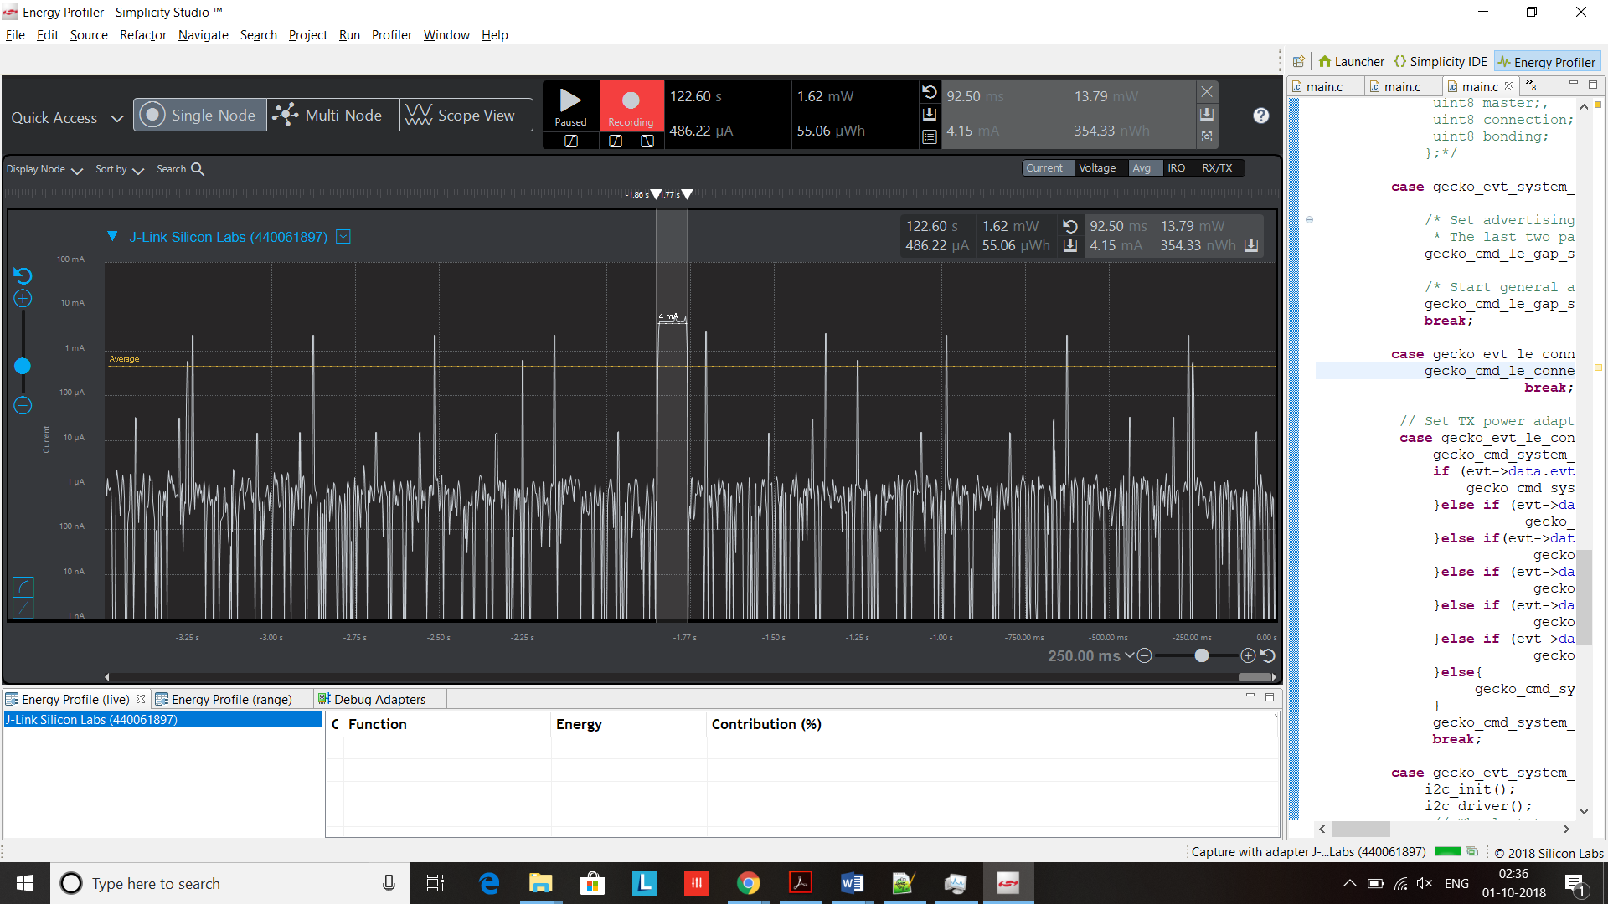

2. Provide screen shot verifying the connection interval setting.

-> Connection Interval

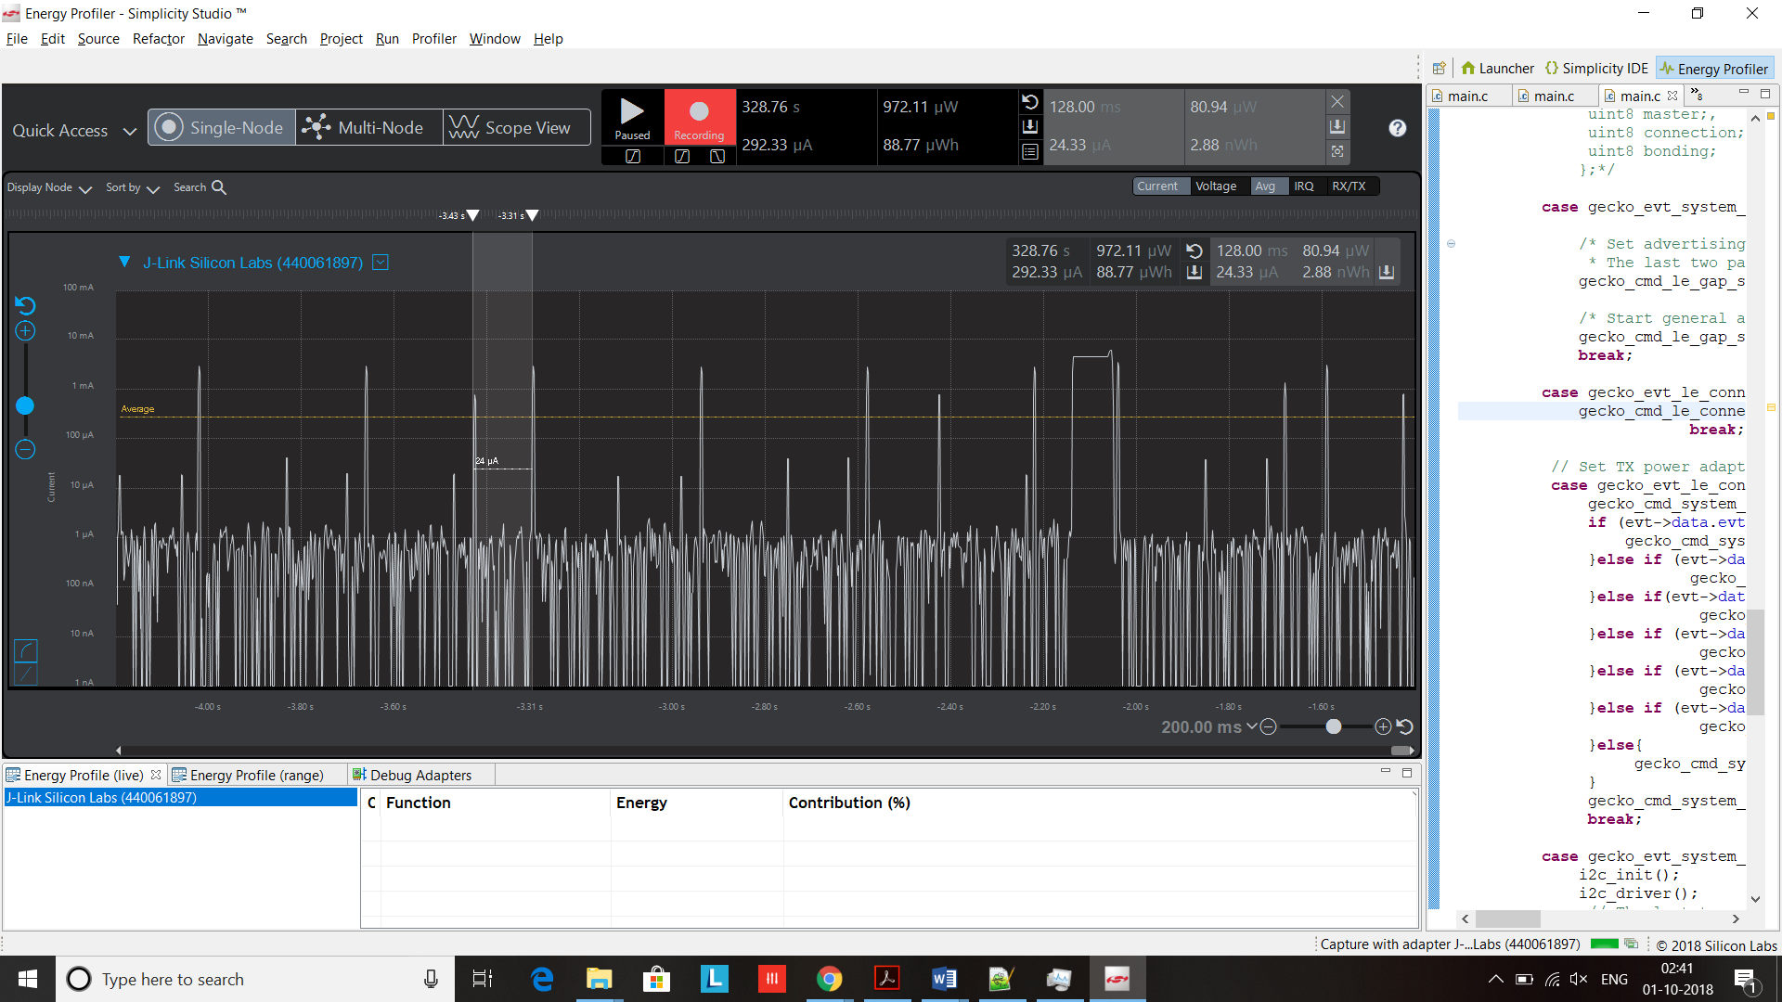

3. Provide screen shot verify slave latency.

->Slave Latency

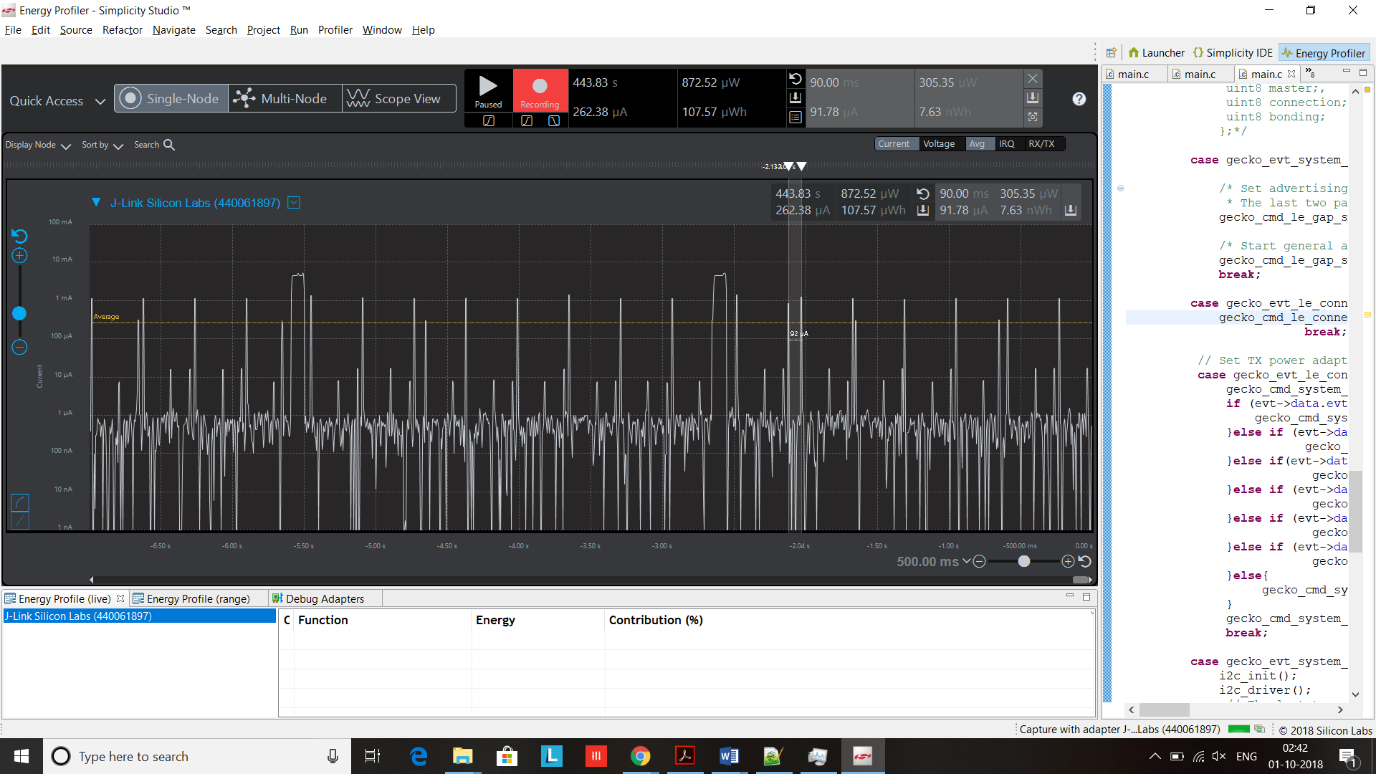

4. What is the average current between advertisements?

-> Average current between Advertisements = 66 uA

5. What is the average current between connection intervals?

-> Average current between connection intervals = 41uA

6. What is the peak current of an advertisement?

-> Peak current of an advertisement = 1.1mA

7. What is the peak current of a data transmission when the phone is placed next to the Blue Gecko?

-> Peak current of data transmission when the phone is placed next to the Blue Gecko = 507uA

8. What is the peak current of a data transmission when the phone is placed 20 feet away from the Blue Gecko?

->Peak current of a data transmission when the phone is placed 20 feet away from the Blue Gecko = 550uA